[King of Thieves] - Final Testing Report
Test Pass #1 – Final Testing Report
Summary
Testing Period | 28.09.2026 - 01.10.2026
Total Time Estimation | 235
Platform | iOS, Android
Build Number | TestFlight (1684 - 1701), Play Store (1699)

Performed Operations

Within the confines of the first test pass SnoopGame team performed:

- Platform test-suite;
- Installation testing;
- InApp Purchases test-suite;
- Functional testing;
- Regression testing;
- Smoke/Sanity testing;
- Exploratory testing;

Bug Priority Distribution

During the testing round, 2 bugs were updated and 19 bugs were found:
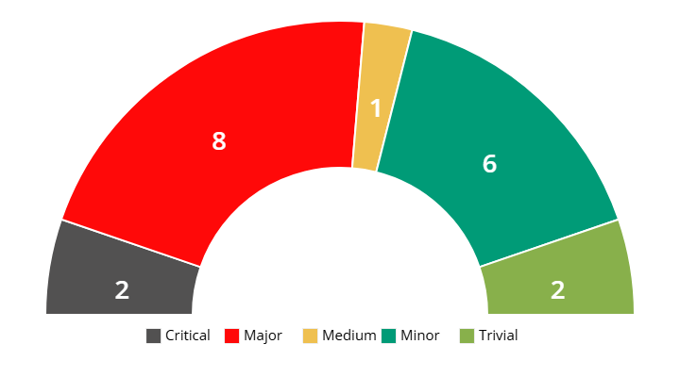
All bugs were reported to JIRA.

Android Installation testing

Device configuration | Check result | Loading Time | Loading Save from  the Main Menu
Samsung Galaxy S23 | Passed | 8,66 | 23,28
OnePlus Ace 5 Racing | Passed | 9,60 | 56,85
Xiaomi 11T | Passed | 10,15 | 37,34
Sony Xperia 5 III | Passed | 10,40 | 68,22
Xiaomi Poco X5 | Passed | 10,95 | 44,75
Motorola Moto G20 | Passed | 8,66 | 23,28
Xiaomi Redmi Note 9 Pro | Passed | 9,60 | 56,85
Samsung Galaxy S8 | Passed | 10,15 | 37,34
Xiaomi Mi A1 (Mi 5X) | Passed | 10,40 | 68,22
Samsung Galaxy Tab S2 | Passed | 10,95 | 44,75

IOS Installation testing

Device configuration | Check result | Loading Time | Loading Save from  the Main Menu
iPhone 17 | Passed | 8,66 | 23,28
iPhone 16 Pro Max | Passed | 9,60 | 56,85
iPhone 15 Pro Max | Passed | 10,15 | 37,34
iPhone 14 | Passed | 10,40 | 68,22
iPhone 12 mini | Passed | 10,95 | 44,75
iPad mini (2019) | 5th Gen | Passed | 8,66 | 23,28
iPad Air 2 | Passed | 9,60 | 56,85

Reported to JIRA

№ | Summary | Link | Priority
1 | There is a game freeze when catastrophes have started | Bug-001 | Critical
2 | Buildings that were opened using the tech tree disappear after loading save | Bug-002 | Critical
3 | Clicking on colony notification doesn't take user to colony view | Bug-003 | Major
4 | Information tooltip of Nuclear Waste blocks the click for construction next to it | Bug-004 | Major
5 | Resources collected by specialist are displayed only a day later | Bug-005 | Major
6 | Resource "Medicine" is not consumed during the Pandemic | Bug-006 | Major
7 | Construction does not continue by other colonists if the builder died | Bug-007 | Major
8 | Dead colonists die again after loading save | Bug-008 | Major
9 | The close button doesn't work on the info window on the global map | Bug-009 | Major
10 | The "Mill" building can be broken by "Magnetic Storm" catastrophe | Bug-010 | Major
11 | Energy production can't be paused by pausing buildings that generate electricity | Bug-011 | Medium
12 | Placing several wells in the same effective radius doesn't affect their productivity | Bug-012 | Minor
13 | Electricity-producing buildings don't shut down during "Magnetic storm" catastrophe | Bug-013 | Minor
14 | Sawmill do not use trees that were grown by the Forester building | Bug-014 | Minor
15 | Some terrains can't be scouted on World Map | Bug-015 | Minor
16 | It's possible to build over the corpses and fence | Bug-016 | Minor
17 | Quantity of water is displayed shifted when it is more than 1000 points in the panel | Bug-017 | Minor
18 | Active working area is still displayed after demolishing a building | Bug-018 | Trivial
19 | Buildings that do not require energy have electricity problem animation | Bug-019 | Trivial
34 | The first building from the list is highlighted after opening construction's slide panel | Bug-020 | Updated
35 | Builders run through mountains when constructing buildings placed behind them | Bug-021 | Updated

Review & Suggestions

Tester #1
TOP 3 best thing
The main gameplay mechanics (movement, traps, win/lose conditions) are intuitive, responsive, and well explained through the tutorial. Once learned, the loop is easy to understand and engaging.
Attack locations, dungeon layouts, and biome-based visual differentiation are clear and readable. Progression is logically gated, preventing players from skipping content and reducing confusion.
Animations, tooltips, highlights, and interactive indicators clearly communicate their purpose. Most actions provide immediate visual feedback, reducing the need for external explanations.
TOP 3 worst thing
The main screen contains many interactive elements (offers, dungeon, throne, totem, traps, doors, ads), which may overwhelm new or returning players after a break.
Some pop-ups behave differently (close behavior, back navigation, skip buttons), which may confuse users and complicate testing and user expectations.
Attack matchmaking, social features, ads, and purchases heavily rely on network stability. Poor connection handling may lead to blocked flows or unclear error states.
Suggestions
Unify close actions, back button behavior, and skip logic across all pop-ups to improve UX consistency and reduce edge cases.
Add clearer error messages, retry options, and safe fallback states when network-dependent features fail.
Introduce contextual hints, reminders, or a “returning player” flow to help users re-orient themselves without replaying the full tutorial.
Improve feedback for locked or unavailable actions. When actions are blocked (no lockpicks, level locked, insufficient currency), provide clearer explanations and actionable hints instead of silent or generic blocks.
Consider adding options such as reduced animations, clearer contrast for traps, and adjustable UI scale to improve readability on smaller screens.
Some features and currencies use similar terms or icons. Align naming and iconography to reduce confusion and learning friction.
Show clearer short-term and long-term goals (next unlock, league requirement, upgrade impact) to help players understand “what to do next”.

